CaRT Business Process Guide

Copying and Customizing Dashboards and Analyses

July 18, 2016

***This document was prepared for the exclusive use of the designated recipient and contains proprietary and confidential information of Sierra-Cedar, Inc.***

***Distribution outside the designated recipient's organization is prohibited.***

# Revision Control

|  |  |
| --- | --- |
| **Document Title:** | **Copying and Customizing Dashboards and Analyses** |
| **Author:** | Dennis Cantrell |

|  |  |  |  |
| --- | --- | --- | --- |
| **Date** | **By** | **Action** | **Pages** |
| 06/28/16 | DC | Created | All |
| 07/18/16 | DC | Revised | All |
|  |  |  |  |
|  |  |  |  |
|  |  |  |  |

Review/Approval History

|  |  |  |  |
| --- | --- | --- | --- |
| **Date** | **By** | **Action** | **Pages** |
|  |  |  |  |
|  |  |  |  |

Table of Contents

Double Click Here to Change Text

Revision Control i

Table of Contents ii

Process Overview 1

Where the Data for This Process Comes From 2

Where the Data from This Process Goes 2

Related Information 3

Prerequisites and Assumptions 3

Related Documents 3

Helpful Hints 3

Key Definitions 4

Customizing Dashboards Created by Others 5

The Basic Procedure 5

Expected Outcomes 10

# Process Overview

*Copying and Customizing Dashboards and Analyses* describes the process for making copies of pre-existing dashboard objects — whether your own or those created by someone else — so that you can edit and customize the objects for your own use. Dashboard objects include all parts of the dashboard (analyses, prompts, text objects, and so forth), including the dashboard itself. The process for copying and editing is the same, whether or not you are customizing entire dashboards or individual objects, and involves two general steps:

|  |  |
| --- | --- |
| Description: sign23 | You need the BI Author’s Role before you can copy and edit dashboards and analyses (reports) created by someone else. |

There are two primary benefits of copying and editing your own or someone else’s dashboard:

1. Saves time by eliminating the need to recreate an example from scratch
2. Ensures consistency of style and formatting

## Where the Data for This Process Comes From

*All data is sourced from Catalyst or Radius. The copied dashboards and analyses are either your own or those created by other users.*

## Where the Data from This Process Goes

*This copying and editing process can be applied to any online, interactive CaRT analysis or dashboard in any of the Side Cart folders.*

# Related Information

## Prerequisites and Assumptions

Before you can successfully complete the steps described in this document, it is either required or assumed that each of the following conditions has been met:

| Prerequisites and Assumptions |  |
| --- | --- |
| Prerequisite/Assumption | Detail |
| User has the privileges of the BI Author Role. | Privileges of the BI Author Role allow copying and (more importantly) editing of other users’ reports and dashboards. |
| User can locate and copy dashboards objects | User must have a basic understanding of the Catalog Manager. |

## Related Documents

| Related Documents |  |
| --- | --- |
| Document Name | Location or Link to Document |
| N/A | N/A |

## Helpful Hints

*When choosing where to paste your copied dashboard for customizing, keep these tips in mind:*

* Any thing copied into your CaRT’s “My Folder” can only be viewed by you. This may be desirable while you are customizing the copy, or if the edited copy will be for your own use, only. Just don’t forget to move the final product to your personal folder in the Side CaRT folder if you want to share it with others.
* Remember: any report object in your Side CaRT personal folder can be viewed or executed by anyone with CaRT access.

## 

## Key Definitions

| Key Definitions |  |
| --- | --- |
| Term/Acronym | Definition |
| Catalog Manager | The primary online tool used to navigate the CaRT system. |
| Side CaRT | Every user has a shared personal folder in the “/Shared Folders/Side CaRT” directory. The folders are labeled by username in UC’s 6+2 format. But these are **public** folders that all other users have access to. |
| CaRT My Folder | Personal folder that only you can access. No one else can view its contents. |

# Customizing Dashboards Created by Others

*This document focuses on the copying and editing of dashboards created by others, as well as copies of your own work.*

## The Basic Procedure

|  |  |
| --- | --- |
| Step 1 | Locate the folder containing the dashboard you want to customize by using the Catalog Manager. |

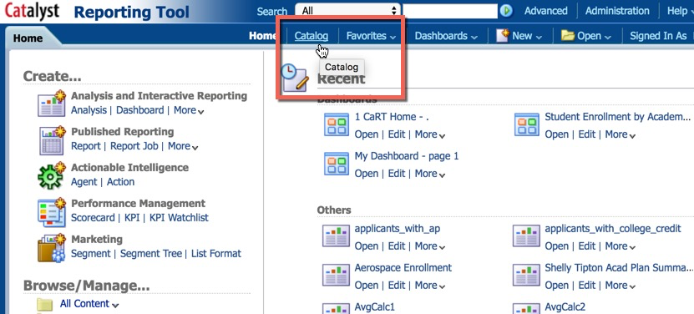

After selecting the Catalog view navigate to the folder whose contents you want to modify.

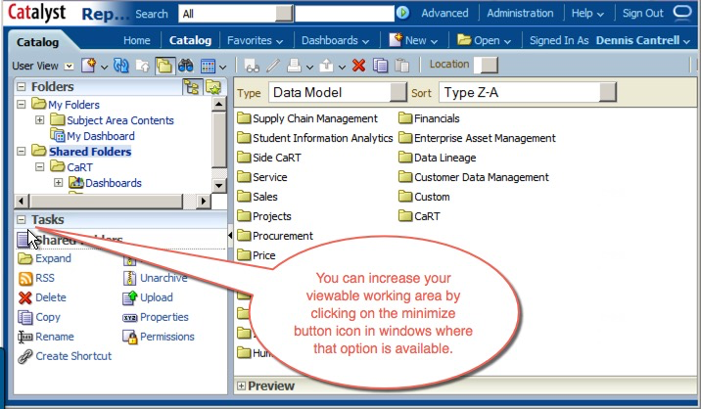

**Navigation: Shared Folders > CaRT > Dashboards > Student Records > University > Library**

|  |  |
| --- | --- |
| Step 2 | Click on the folder of a dashboard of interest (left panel), and then click on the Copy icon on the Catalog menu bar. |

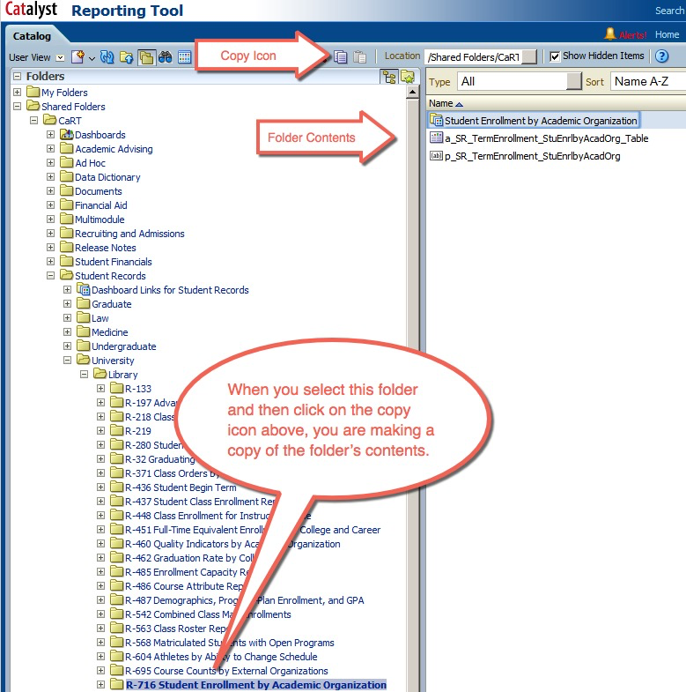

|  |  |
| --- | --- |
| Description: caution_bevel | When copying make sure to use the copy icons. **Do not attempt to “click and drag” to the desired folder.** Doing so will actually move the dashboard from its original location instead of making a copy. |

|  |  |
| --- | --- |
| **Step 3** | Now navigate to the desired location, your own “My Folders,” for example, and click the paste icon to create a copy of the folder’s contents. |

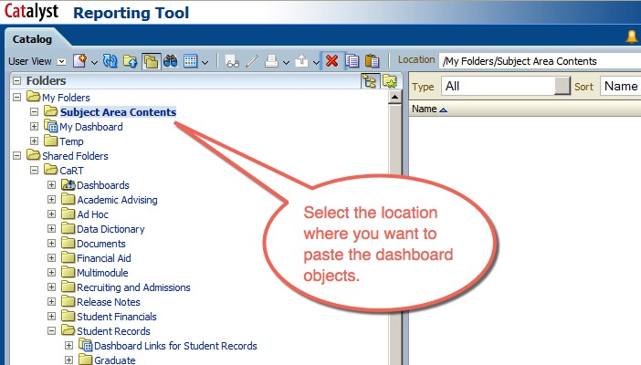

|  |  |
| --- | --- |
| Description: sign23 | If copying a single dashboard page (as opposed to a folder containing an entire dashboard and all of its objects, as shown here) you must paste it onto another dashboard such as “My Dashboard.” |

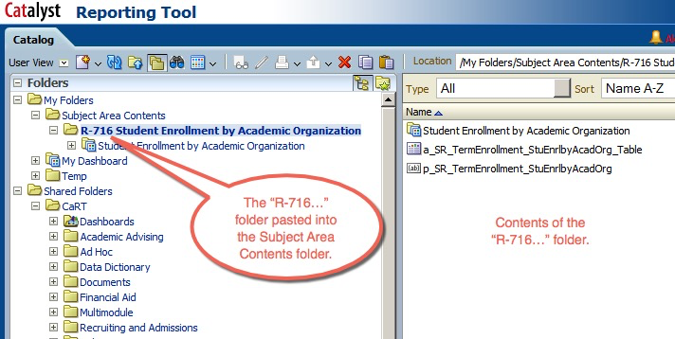

|  |  |
| --- | --- |
| **Step 4** | To customize the dashboard, you first have to re-establish all the links by re-dragging each object from its new folder location onto the dashboard’s work area. Only then can you begin customizing the dashboard because right now all the objects are still pointing to their original locations. So begin reestablishing the links by selecting the pencil icon on the Catalog menu bar or by right-clicking on the object itself. |

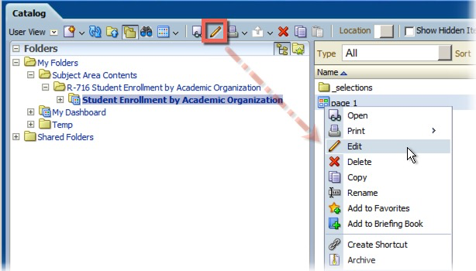

|  |  |
| --- | --- |
| **Step 5** | Once the dashboard is open for editing, drag each object from its new location back onto the work area, into the appropriate section and then reselect the view. Delete the original object and continue until all objects and views have been relinked. |

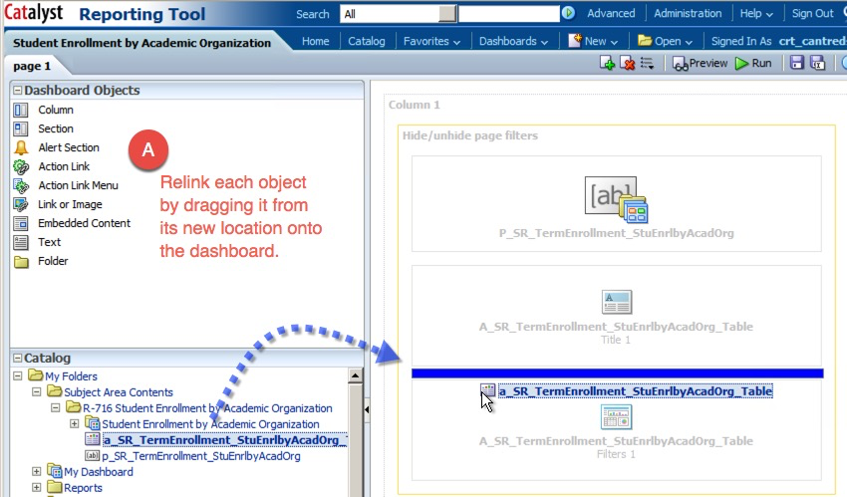

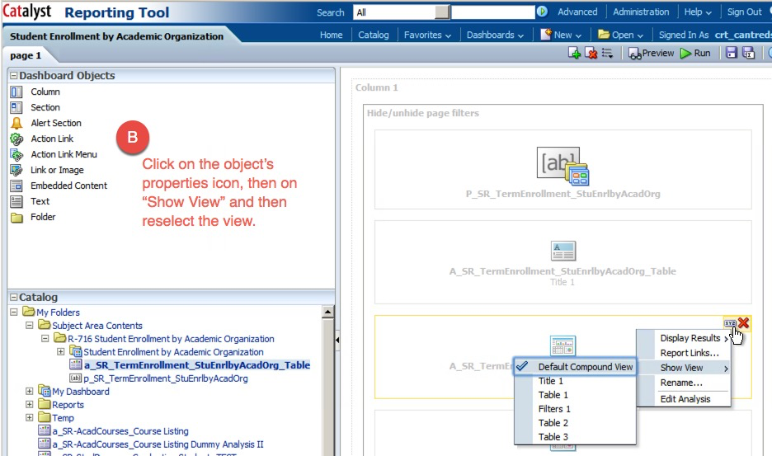

Now that all objects have been relinked, you can edit and customize as necessary. Once your edits are complete, don’t forget to save the changes to your new customized dashboard.

|  |  |
| --- | --- |
| Description: caution_bevel | But, first, another caution: If *only* the dashboard is copied and not the folder contain all of its supporting objects, it’s important to remember that although the links to the objects on the copied dashboard will *not* be broken, any editing of the dashboard objects will also only affect the originals. |

**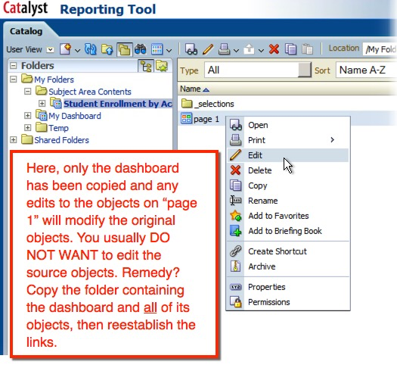**

|  |  |
| --- | --- |
| Description: caution_bevel | Also, be aware that if you move any of the dashboard objects to another location, the dashboard will *not* be able to locate them. You will need to manually drag and drop the moved objects from their new location back onto the dashboard and reestablish the links just as you would in the process described earlier in this document. |

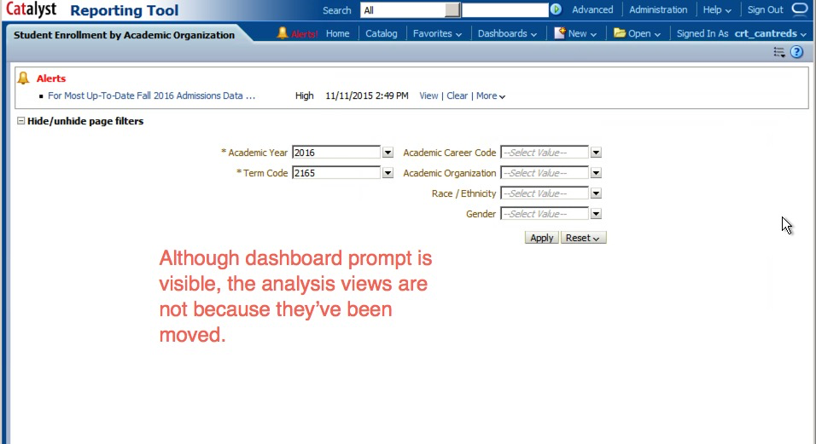

Editing the dashboard reveals which views are missing because each will have a caution icon (a yellow triangle with an exclamation point) next to it. Relocate the objects and drag them back onto the dashboard, then delete the objects with the caution icons.

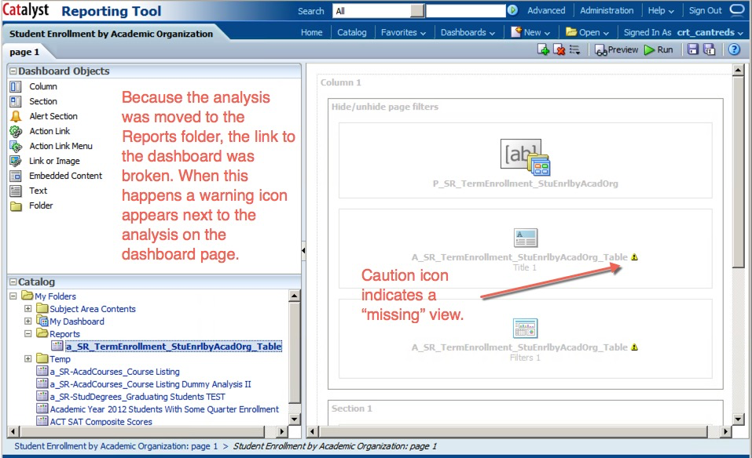

# Expected Outcomes

Using this Business Process Guide, you should be able to obtain the following results:

* Locate a dashboard object you want to customize
* Copy and paste the object to a desired location for editing
* Reestablish all the object links so they are pointing to the new location
* Customize the object and make available to other users